**Lab 3 SystemAdmin2**

• Install ftpd service on your laptop

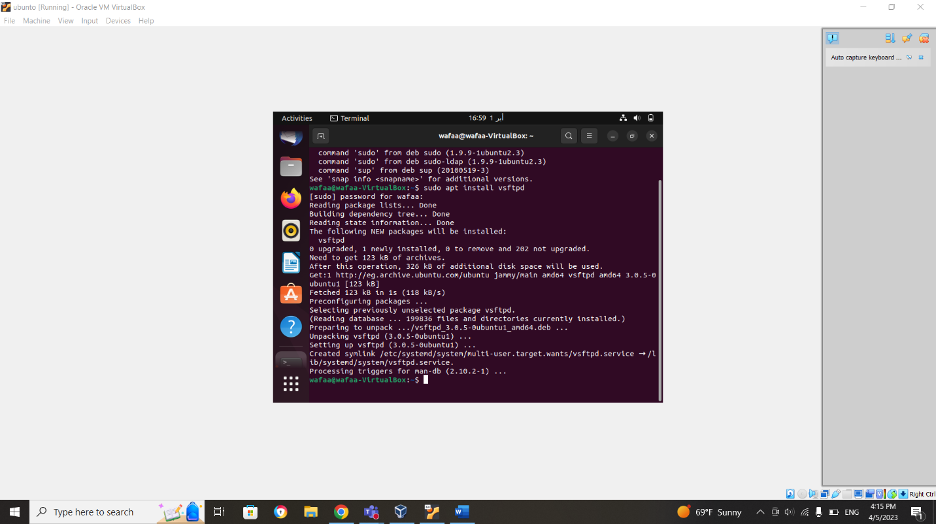

• enable port 21 and 20 (tcp) using iptables command using INPUT chain

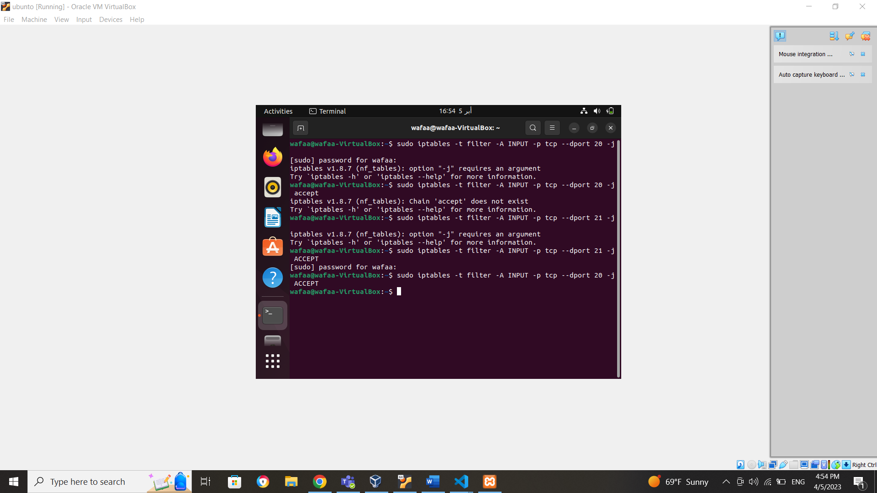

• connect to ftp server (e.g: localhost) and browse the current directory

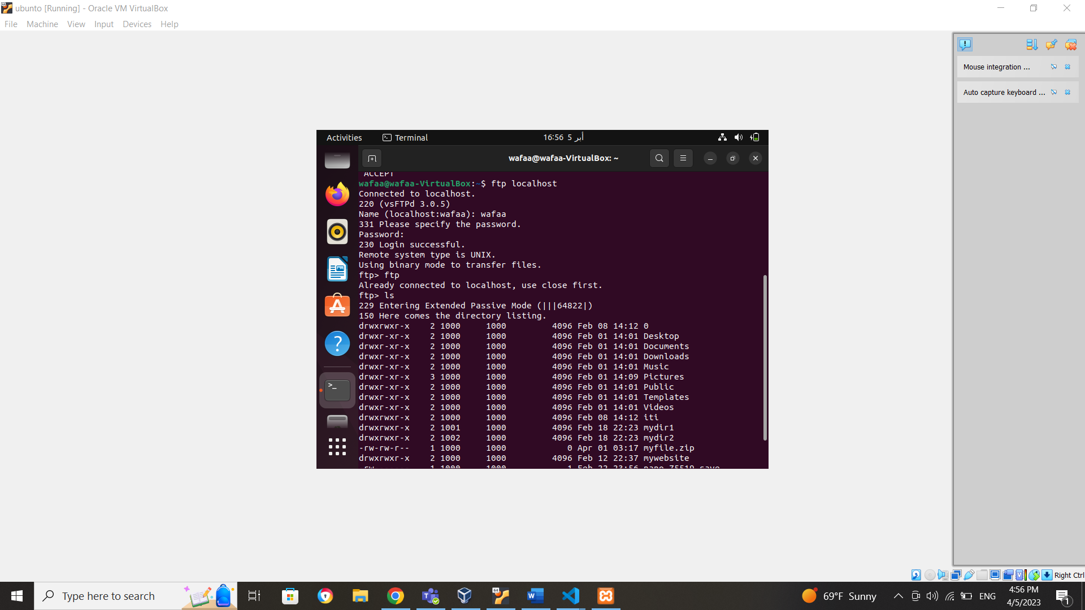

• enable ufw service

• block port 20 and 21 (tcp) using ufw

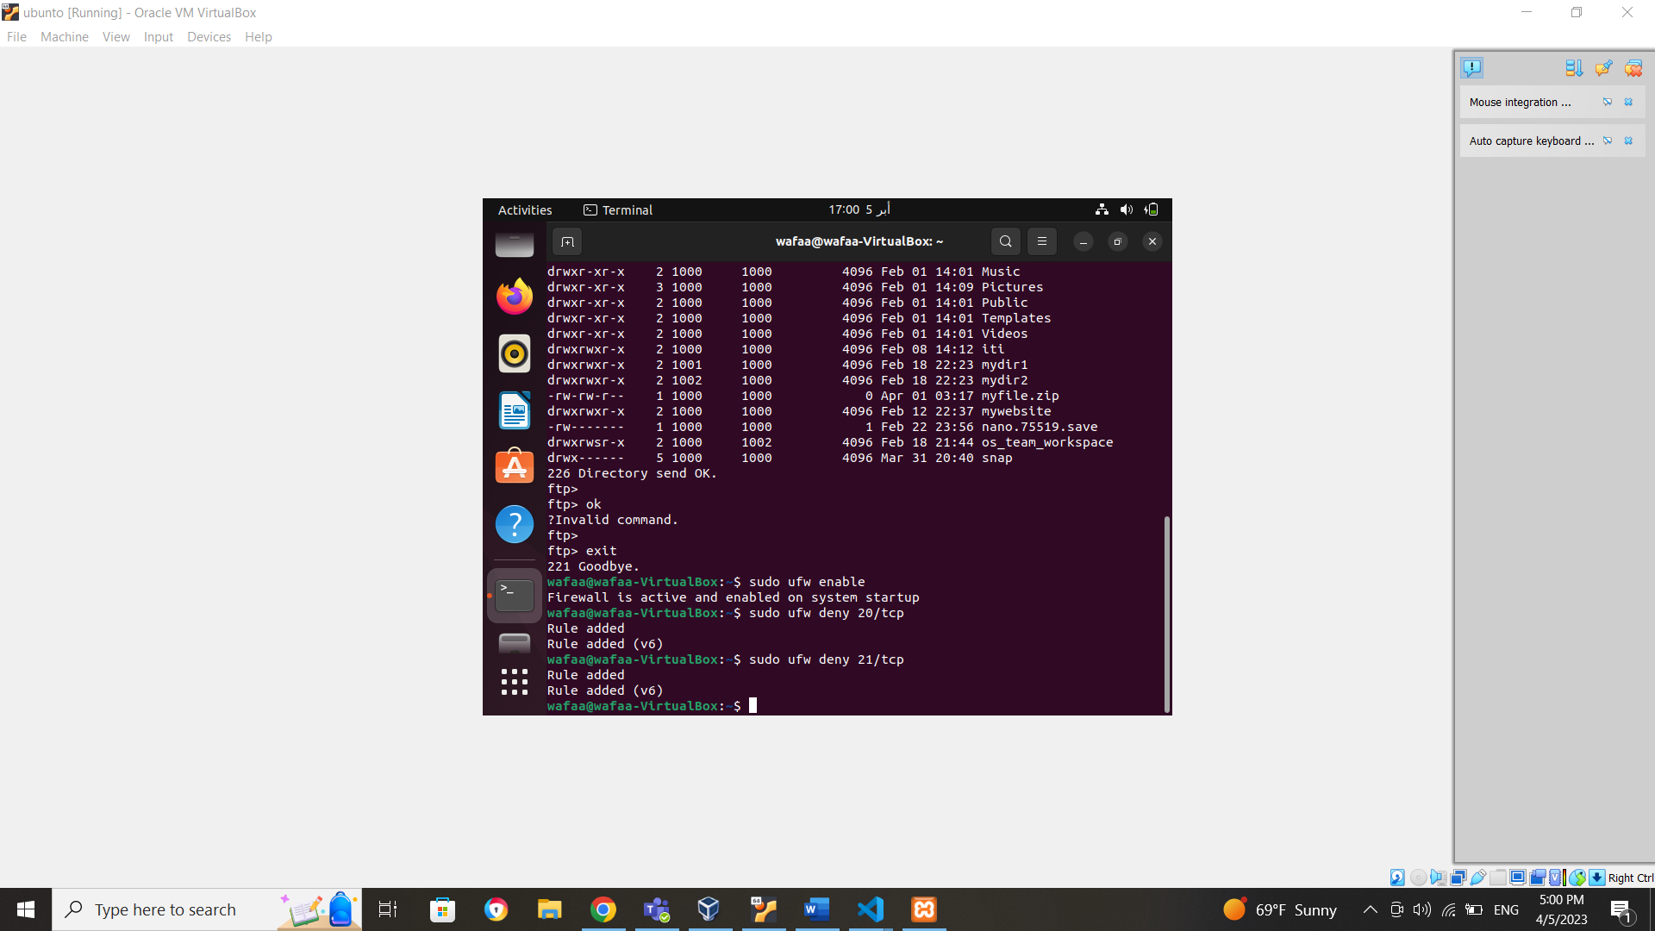

• try to connect to ftp service.

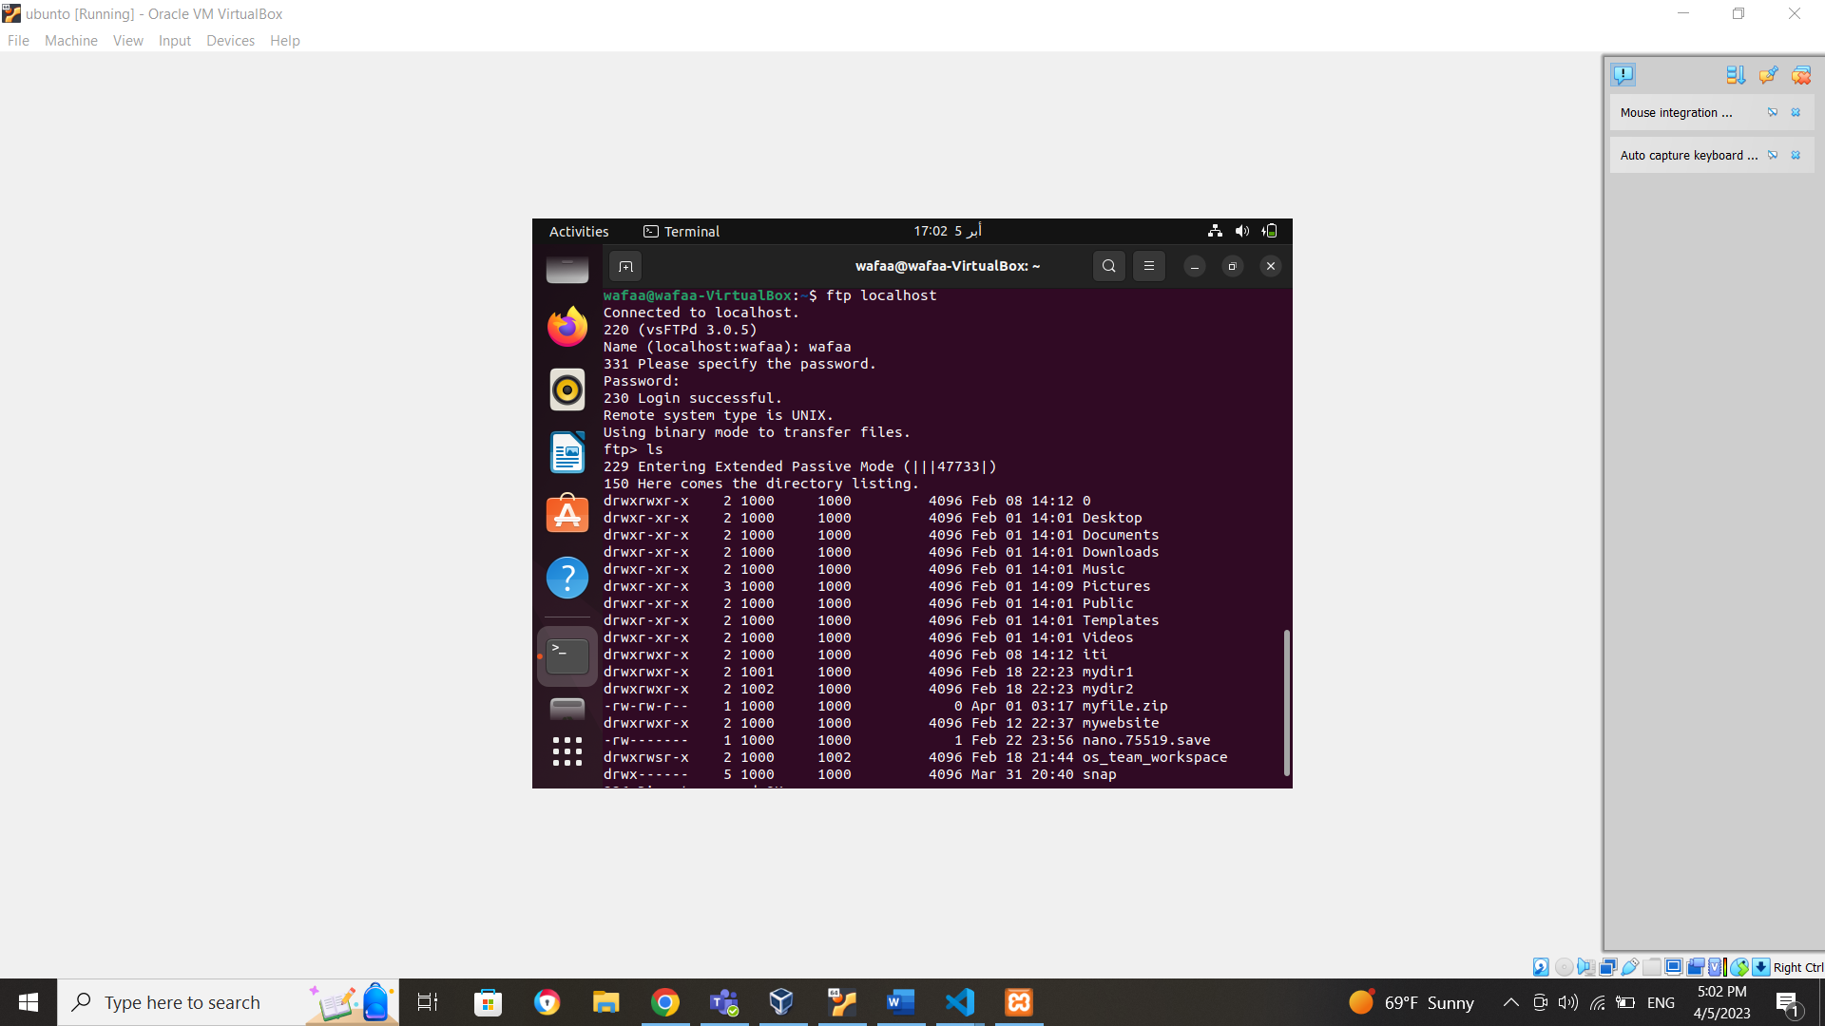

• capture the ufw log to detect the blocked operation

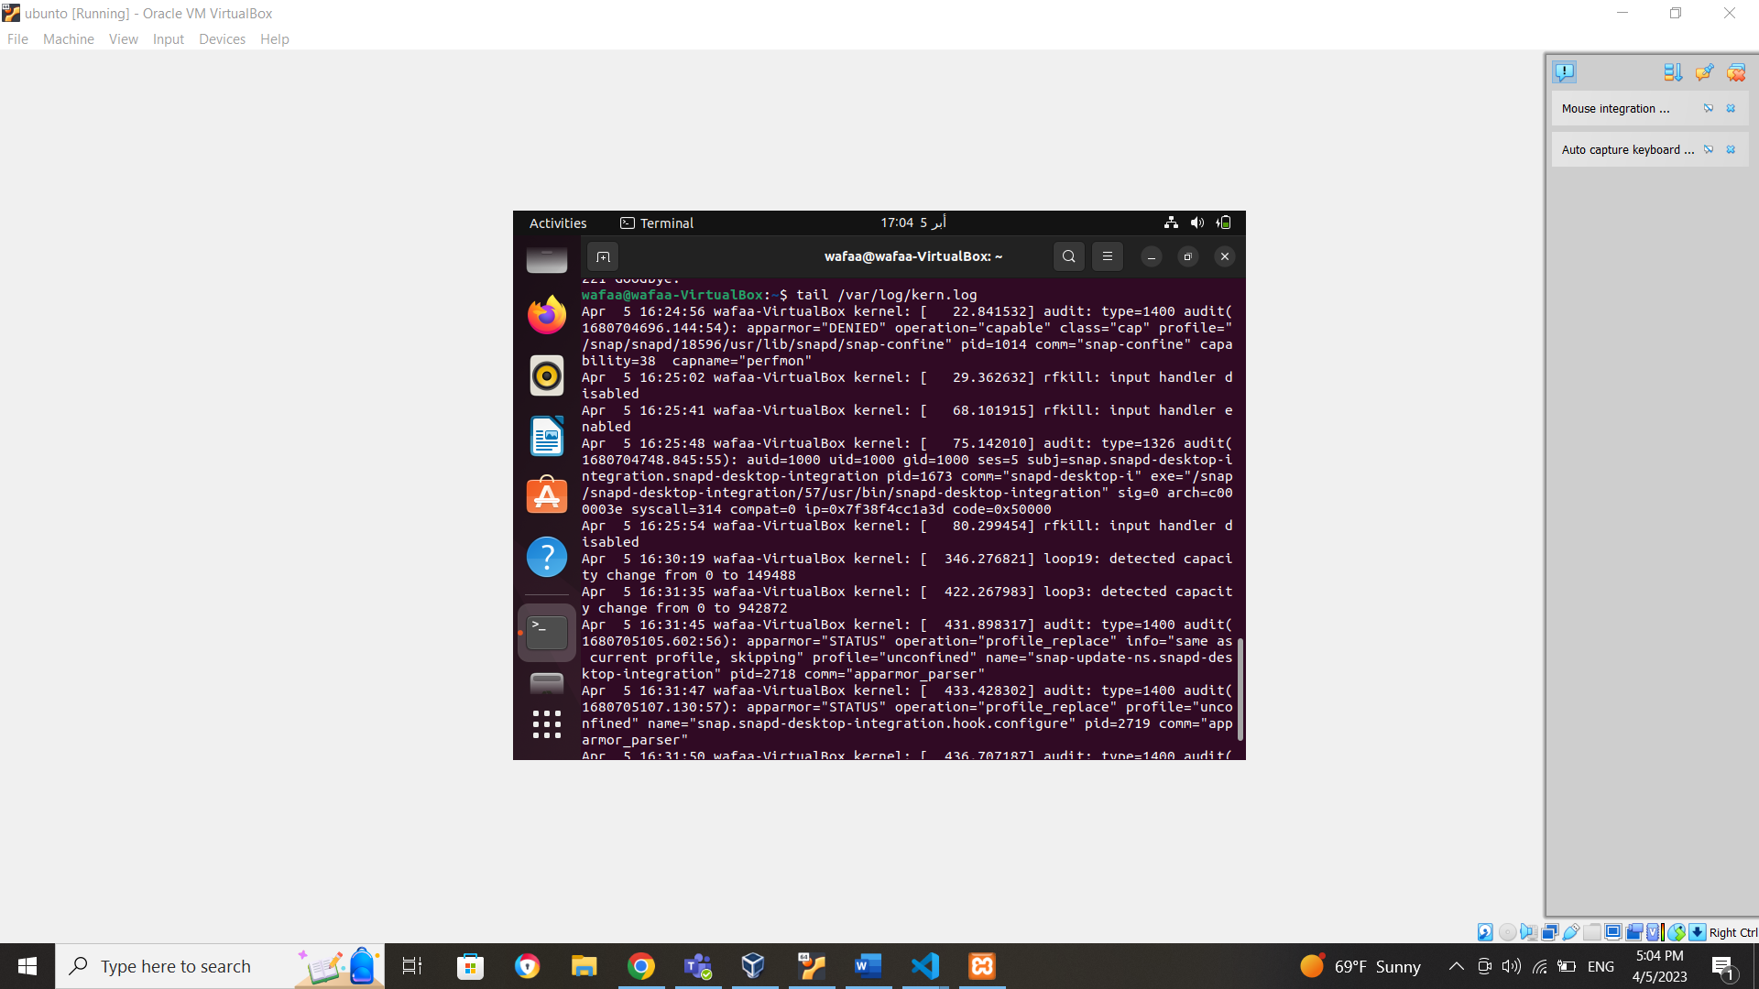

• install nfs service on your system

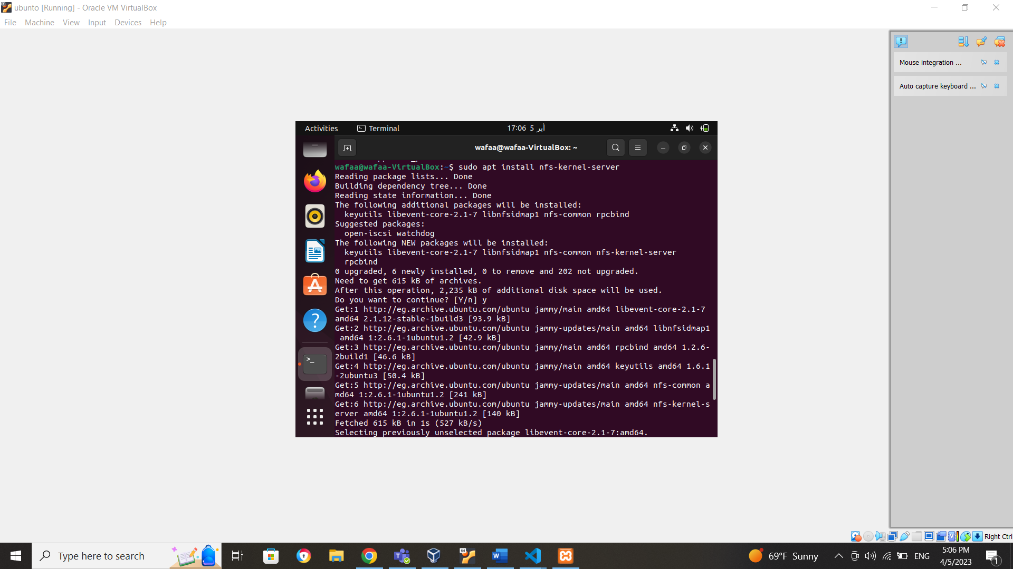

• enable nfs service on the firewall

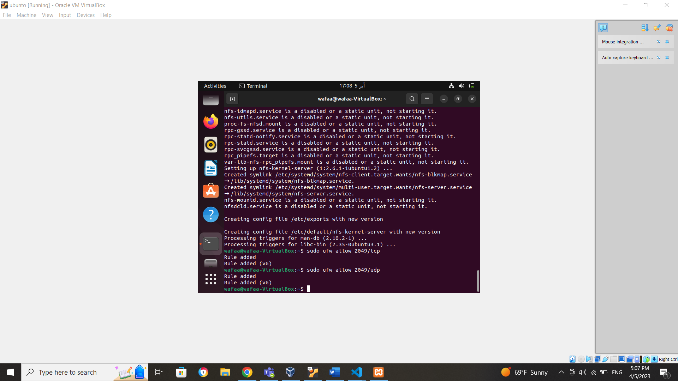

• create and share /tmp/shares folder using exportfs command and /etc/exports file

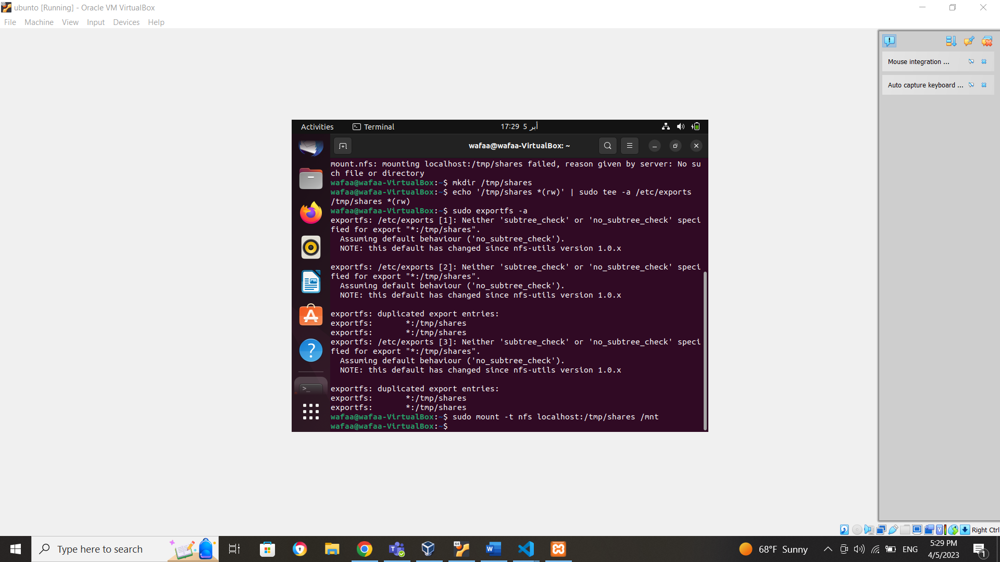

• mount the remote share on /mnt folder (you can using localhost as well)



• copy some files to the remote share

Scp /tmp/file.txt /mnt

• save iptables rules to /tmp/iptables-backup file

Sudo iptables-save > /tmp/iptables-backup

